参考：http://www.mathcs.emory.edu/~cheung/Courses/170/Syllabus/13/hanoi.html

String hanoi( int nDisks, int fromPeg, int toPeg )
{

int helpPeg;

if ( nDisks == 1 )
{
/* ------------------------------------------------------
Solving a trivial (base case) Tower of Hanoi problem:
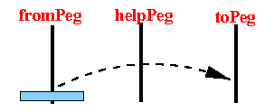
------------------------------------------------------ */
return( "Do this move: fromPeg --> toPeg" );
}
else
{
/* ------------------------------------------------
Solving a non-trivial Tower of Hanoi problem:
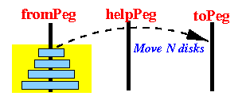
------------------------------------------------ */

/* ------------------------------------------------
Determine the helpPeg
------------------------------------------------ */
helpPeg = peg index that is not equal to fromPeg and toPeg;

/* ---------------------------------------------------
First: solve this smaller Tower of Hanoi problem:
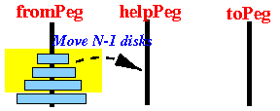
---------------------------------------------------- */
sol1 = hanoi( nDisks-1, fromPeg, helpPeg ); // Sol1 looks like: 1 -> 3, 1 -> 2, ...

/* ---------------------------------------------------
Next: do this move
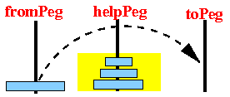
---------------------------------------------------- */
myStep = "Do this move: fromPeg --> toPeg";

/* ---------------------------------------------------
Finally: solve this smaller Tower of Hanoi problem:
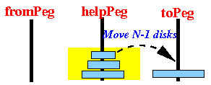
---------------------------------------------------- */
sol2 = hanoi( nDisks-1, helpPeg, toPeg ); // Sol2 looks like: 1 -> 3, 1 -> 2, ...

/* ===============================================
How to use the solutions sol1 and sol2 to
solve hanoi(nDisks, fromPeg, toPeg):
1. first making the moves in sol1
2. then do myStep
3. finally, do the moves in sol2
=============================================== */
mySol = so1l + myStep + sol2; // mySol looks like: 1 -> 3, 1 -> 2, ...

return ( mySol );
}

